**Andrew Chellis**

Container Department

Assistant Team Leader

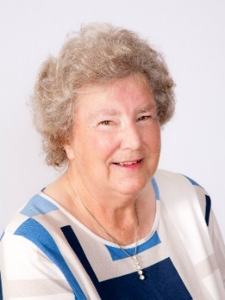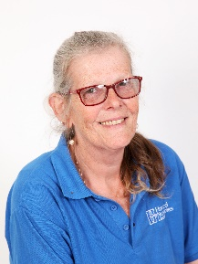

**Christine Howard**

Managing Director

**Sheila Howard**

Director

**Marcel Willems**

Operation Manager

**Aaron West**

Sales

**Peter Gibbs**

Sales

**Vicki Stannard**

Sales & Stock

**Amanda Huckle**

Accounts Assistant

**Louise Worthington**

Office Administrator



**Jenny Piper**

Propagation

Team Leader

**Peter Baxter**

Open Ground

Team Leader

**Louise Calver**

Splitting Department Team Leader

**Gavin Erith**

Container Department

Manager

**Vicky Johnson**

Dispatch

Team Leader

**Jennie Piper**

Dispatch

Assistant Team Leader

**Steven Hughes**

Lorry & Van Deliveries

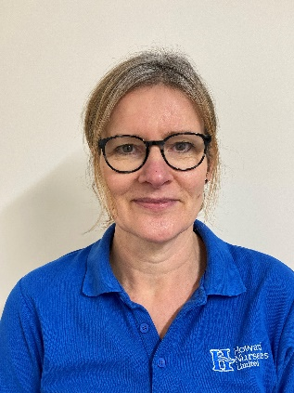

**Diane Drake**

Accounts